**Experiment 1-** Design a LED Flasher

Circuit Diagram:

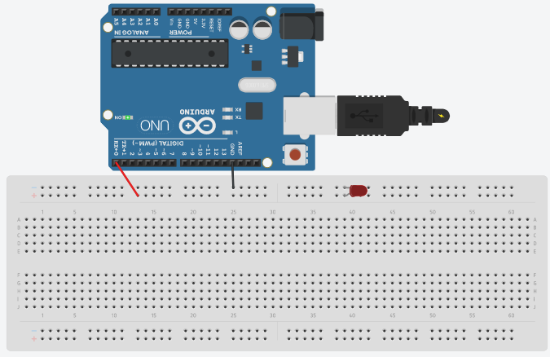

**Theory-**

Concepts Used:

1. Working of Arduino UNO
2. Coding in Arduino IDE and syntax of the same
3. Working of LEDs (Light emitting diodes)
4. Making connections on a Breadboard.

Learning & Observations:

Use of Arduino board and coding in Arduino IDE: Arduino board is very systematical way to show how the circuit is working. Coding syntax is this is similar to the coding in C language which we already know. I learnt the importance of delay function as the micro-controller is fast and capable.

I observed that there are many other interesting functions we can perform with Arduino like blinking of LED.

Problems & Troubleshooting-

I encountered a problem while uploading the code and I rectified by removing all the errors mainly syntax error.

Precautions-

1. Remember to declare all the ports in use in digital input/output in the right way.
2. Check whether all your wire connections are correct and tight.
3. Delay gap should be correct for testing and program also should be correct.

Learning Outcomes-

Skills that I have acquired are starting knowledge of how to use Arduino UNO and slight Idea of its utilization in other scenarios.